Module A.2 :Inside a PC

**Level 1**

1&2 Image of Computer with Labeling.

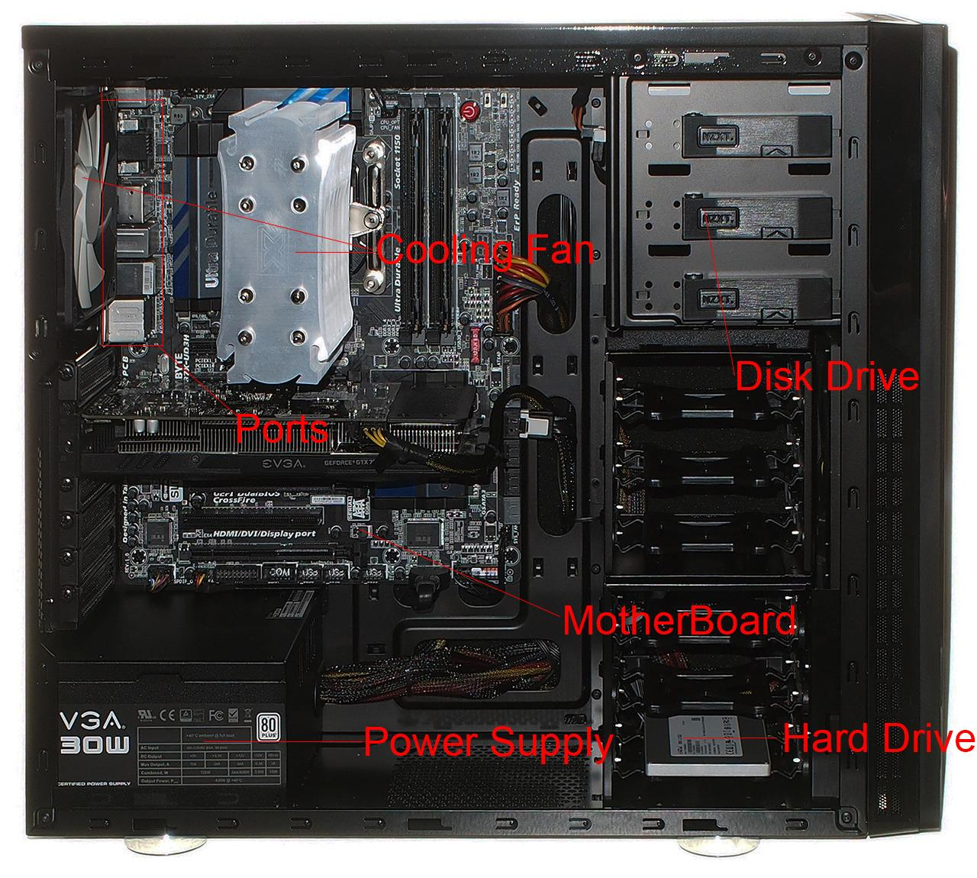

3. Currently there are four different types of motherboards XT, AT, Baby AT and ATX. Each motherboard is different with XT being the oldest with no ports and considered old time mother boards while ATX motherboards are the newest motherboards and have many ports.

4. There are four different types of hard drives. PATA, SATA SCSI, and SSD. Hard drives slowly changed from 5.25 inch drives to 3.5 inch drives then 3.5 inch drive to 2.5 inches. The better storage helped pave the way to better internals because it allowed more possibilities. The capacity of hard drives changed from 20Mb SSD is $1000 while 1 Tb SSD is around $200-$500.

**Level 2**

1&2

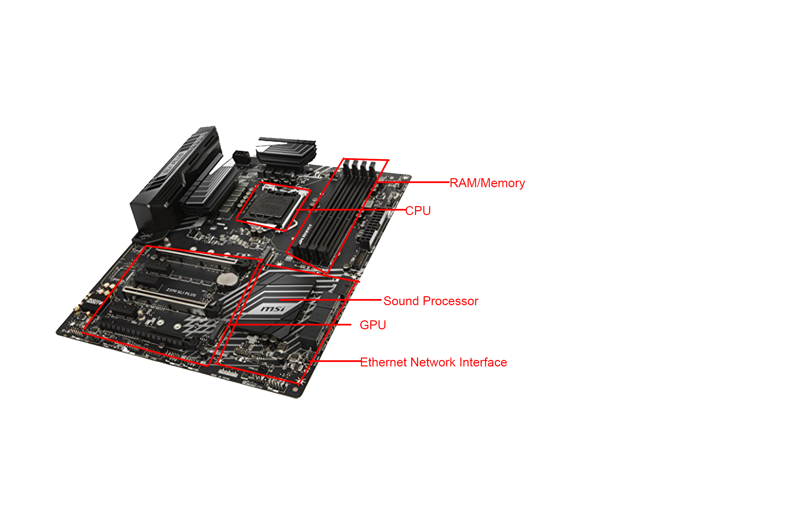

3. Currently AMD (Advanced Micro Devices) and Intel lead the market for CPUs. Most CPUs today are made by one or the other. Their speed and capacity have gone up through the years and became what it is today. The component has changed throughout the year to fit into slots of the new motherboards. Some motherboards have more pins for CPU than others, therefore making some CPU not compatible with certain motherboards.

4.Ram has changed throughout the years and only have gotten better. The amount of ram varies along with the value of them. They could come with 500mb to 256gb of ram. A standard computer usually has 4gb of ram so 32gb is too extreme.

**Level 3**

1. 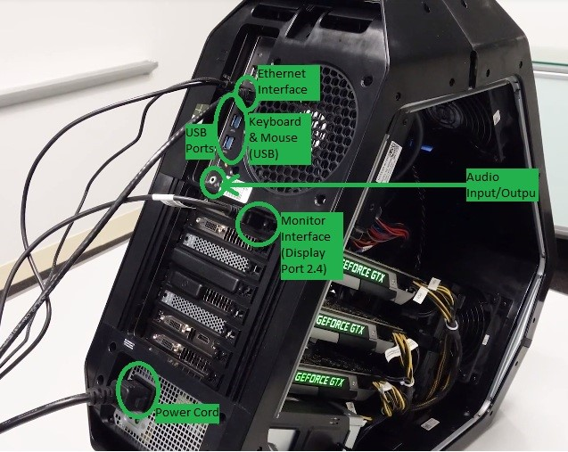
2. The most common monitor is usually 1080p with a refresh rate of 60. There are monitors that have more than 1080p like 4k and 8k but the technology for higher resolution is extremely limited. Better monitors usually have better refresh rate like 120 and 144.
3. Items that are used to store items separate from the computer. USBs and Disk are examples of external storage device because they are able to store things without being connected to a computer to device. External storage can be found online like cloud storage or in physical forms like USBs.
4. Presentation is not needed (Teachers Word)